Blog Writing Requirements

|  |  |
| --- | --- |
| Blog topic: | Agile and DevOps: Optimize Your Development and Operations |
| Blog category: | Engineering |
| Blog Keywords | Optimize operations with DevOps |
| Sample blogs link: | https://mentormate.com/blog/agile-and-devops-optimize-your-development-and-operations/ |
| Reading time | 12 min |
| Readers type: | Startup decision makers |
| Industries | None. |
| Required word counts: | 1100 |
| Writers Area | |
| Total Word Count (Include Blog, Social, Email count) |  |

Objective of the blog:

A goal focused blog addressing potential customersbelongs to a specific industry, their problems – highlighting their specific issues/problems, connecting problems with losses, providing possible solutions, concluding whole topic with objective to achieve…

Notes: final draft should have a sample of all the necessary assets (style formatting, images, and any special instructions for the designer) required to post on the website.

Tags or labels should be mentioned separately

Write Blog Here…..

Instruction for writer:

Image: Use relevant images that support paragraph content, the way used in priority reference link.

Tags: During development avoid web application mistake

Always write content in same/one file.

----------------------------------------------------------------------------------------------------------------------------

**Agile and DevOps: Optimize Your Development and Operations**

**What is SDLC(software development life cycle)?**

The process in which we formulize that how we developed a software within the given budget and resources . It involves composing an arrangement of interrelated programming code, which gives the real picture for the software creation.It comprises of planning , defining , designing , building , testing and deployment. The life cycle characterizes a technique for making the quality of software and the generally advanced the process of development along with standardized approach.

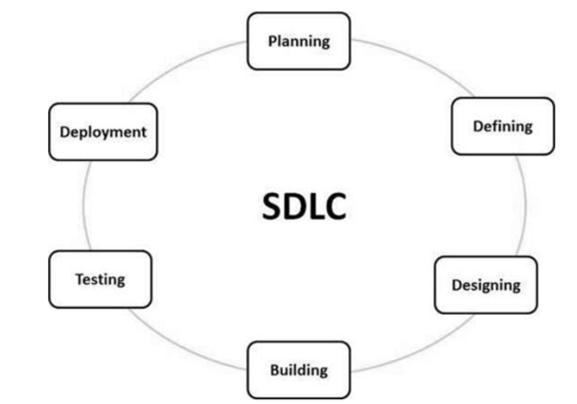

**Software development methodologies:**

There are lots of software development methodologies and applicable for specific projects not for all. All methodologies have distinctive qualities and shortcomings and exist for distinctive reasons. Here’s an the list of the foremost commonly utilized computer program improvement methodologies.

* Agile
* Devops

**What is Agile?:**

The term “Agile” was coined in 2001 within the Spry Pronouncement . “Agile may be a term used to depict approaches to computer program improvement emphasizing incremental approaches , group collaboration, arranging, and continual learning , developmental improvement, early delivery, and nonstop advancement, and it empowers adaptable reactions to change.In computer program improvement, agile include finding prerequisites and developing arrangements through the collaborative of self-organizing and cross-functional teams and their customers.

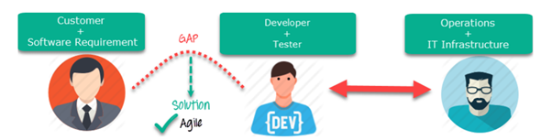

**What is DevOps?**

DevOps is the combination of operations and approaches that is for organization’s capacity to convey applications and software more faster than conventional computer program. This speed empowers organizations to superior serve their clients and compete more effectively within the market.

DevOps is almost following the boundaries between customarily groups, advancement and operations. Beneath a DevOps model, development and operations groups work together over the whole program application life cycle, from improvement and test through sending operations.

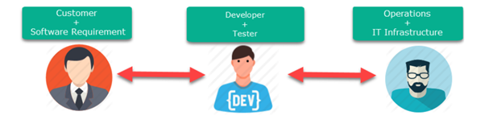

**Misconception that Agile and DevOps:**

There's a common misguided judgment that agile and DevOps cannot work together, which does a disservice to everybody within the program development and in related field. In reality, both approaches can altogether include straightforwardness, review and adaption to way better empower item to create, provide and support complex items. Both agile and DevOps encapsulate extraordinary thoughts and enthusiasm that can include esteem to how groups work, guaranteeing the victory of their organization in a world where commerce is both driven and disrupted by software.

Both agile and DevOps want to provide esteem to clients in a more successful way, but from diverse beginning points . Agile with the engineer, and DevOps from operations. Their accentuation moreover changes, driving individuals to accept that they are distinctive things. Agile emphasizes group intuitive, culture and values, whereas DevOps emphasizes conveyance pipelines and flow.

**Agile and DevOps Can Work Together:**

Agile and DevOps may be diverse, but that doesn’t mean ought to receive superiority to one another.The Agile technique and the DevOps technique can work together and give a incredible efficiency.

“The two terms are certainly diverse; the agile focus on an iterative approach to improvement, and the devops brings two traditionally isolated areas together one is improvement and other is operations, that are ordinarily separated. But the extreme objective of each one is of both to create collaboration and satisfaction to the customer,”.

The great news is that it's not essential to commit to one approach over another. A blend of both techniques can be utilized to guarantee and increased productivity. Both have major parts to play when it comes to computer program advancement and arrangement, and one can be utilized to empower the other.

DevOps and agile are not commonly same. Any organization transitioning to DevOps ought to easily shifted to agile workflows.When utilized together, both processes make successful software , more advancement and [lead to superior products.](https://www.golpik.com/golpik-deliver-great-web-products/)

Agile and DevOps are particular, in spite of the fact that their similitudes lead individuals to think they are one and the same. This does both agile and DevOps a disservice. Both are computer program improvement strategies; there's no debating this.Agile has been around for over 20 a long time, and DevOps came into the picture decently recently.

**Merging Agile and DevOps:**

There are numerous points of interest that are common in agile and DevOps. Counting, speeding up performance, higher client demands fulfillment, and successful collaboration inside a team.Combining the core of DevOps with the culture of agile requires changing inexisting methodologies and operations but having litte changes.

·  **Understanding:**

The agile technique requires individuals who take active part in projects. Common understanding is particularly vital for both agile and devops . To effectively deliver the product, they have to be know each step required to convey

the product.

· **Collaboration:**

DevOps includes the improvement in group working for particular operations. The already specified parts includes all aspects of the preparation and operations.

·  **Practices:**

Both follow lots of practices and repitition just for the sake of fullfilling user demads and expectations .

· **Automate workflows:**

As mechanization is an fundamental portion of DevOps improvement, it ought to be included within the agile workflow and extend its working mechanism. Rising fields,follow automation from manual workflows within the IT environment.

·  **Measure success:**

Blending agile and DevOps moreover includes evaluating and measuring the end-to-end development.

**Agile Vs Devops:**

**Agile:**

* Agile follow iterative approach which centers on collaboration, client input, and little, quick releases.
* Agile makes a difference strategy for complex projects.
* Agile focusses on early changes.
* Agile strategy can be executed only for strategic models like a sprint, secure and scrum.
* Agile advancement emphasizes to prepare all group individuals with different skills sets and rise their skills.
* Small Group is usually used agile developement process .
* As littler is the group, the less individuals on it, the speedier they can move.
* Agile follow flexible developement in terms to dates.

**Devops:**

* DevOps is considered a way of bringing improvement and operations groups together.
* DevOps main focus is to end-to-end building processes.
* DevOps is consistent on testing and delivery.
* The essential objective of DevOps is on collaboration, so it doesn't have any commonly acknowledged framework.
* DevOps isolates and spreads the ability sets between the improvement and operation teams.
* DevOps try to fullfill development on exact dates.
* The actual objective is to convey code day by day or each few hours.
* Relatively bigger group use Devops because it includes all the stackholders.

**Final Thoughts:**

With this analysis we concluded that, both Agile and DevOps bring a successful result for the end-user and customers, in a more productive way but from diverse points and perspectives. Agile focuses on making development and improvement cycles more proficiently, whereas DevOps brings the operations team into play to empower nonstop integration and persistent delivery. Both accept in quick computer program improvement, and their standards are based on how quick computer program can be created without causing hurt to the client or operations.